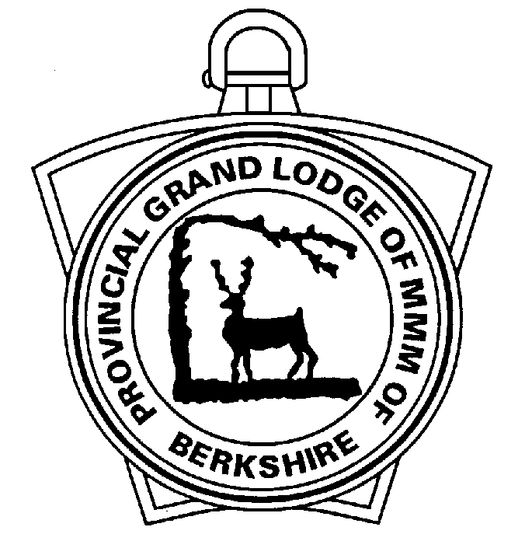

Provincial Grand Lodge of Mark Master Masons of Berkshire

Recommendation for Provincial Royal Ark Mariner Grand Rank

Please use this form to notify the Provincial Grand Secretary for members you wish to nominate for Provincial Royal Ark Mariner Grand Rank.

Lodge Name |  |  |  |  |  |  |  | No.
Members Surname |  |  |  |  | Forenames
Date of Birth
Address (Line 1)
Address (Line 2)
Address (Line 3)
Town
County
Postcode
Telephone No.
Mobile No.
Email address
Date Elevated |  |  |  |  |  | Date Installed
Ceremonies Conducted: |  |  | Elevation (Yes/No)
 |  |  | Installation (Yes/No)
 |  |  | Quality of Work (V Good/Good/Fair/Poor)
Is he a regular attendee of: |  |  | Lodge meetings (Yes/No)
 |  |  | Rehearsals/LOI (Yes/No)
 |  |  | Committee meetings (Yes/No)
Personal Report (Please include comments from the Commander and Scribe with regards to his involvement in Lodge activities, particularly since passing the Chair)

Scribe (Enter Name) |  | Date

Please return to the Provincial Grand Secretary in the strictest confidence.

