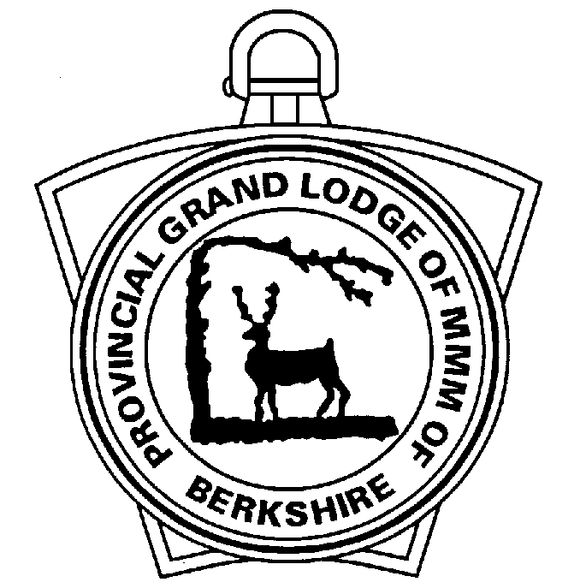

Provincial Grand Lodge of Mark Master Masons of Berkshire

Recommendation for Royal Ark Mariner Grand Rank

Please use this form to notify the Provincial Grand Secretary for members you wish to nominate for Royal Ark Mariner Grand Rank.

Lodge Name |  |  |  |  |  |  | No.
Members Surname |  |  |  |  | Forenames
Date of Birth
Address (Line 1)
Address (Line 2)
Address (Line 3)
Town
County
Postcode
Telephone No.
Mobile No.
Email address
Date Elevated
Date Installed as Commander
Lodges of which he is a Past Commander
Year Received Provincial RAMGR
Personal Report (please include relevant additional information)

Scribe (Enter Name) |  | Date

Please return to the Provincial Grand Secretary in the strictest confidence.

